# CS 340 README Template

Alex Surprenant

## About the Project/Project Title

## Motivation

*The purpose of this project is to create an accessible and functional UI for customers of Grazioso Salvare to be able to access and navigate through a database of animals, particularly dogs. The customer should be able to navigate using a dropdown menu, and view the animals location, and what distribution of Grazioso Salvare’s database contains animals of each type.*

## Getting Started

*In order to run a local copy of this project, the user must download the CRUD.py file. The file can be opened and run in the PyCharm IDE. The user must also have a copy of the IPYNB file, which contains the main functionality of the project.*

## Installation

*The user of this program will need to have MongoDB as well as PyMongo installed on their machine. It would also be helpful to have the PyCharm IDE installed, however other options for running a python file exist.*

## Usage

*Use this space to show useful examples of how your project works and how it can be used. Be sure to include examples of your code, tests, and screenshots.*

### Code Example

This code is an example of how the menu selection dropdown is implemented.

*html.Label("Select animal worker type", style={"width": "40%"}),*

*dcc.Dropdown(*

*id="filter-type",*

*options=[*

*{"label": "Water Rescue", "value": "Water"},*

*{"label": "Mountain and Wilderness Rescue", "value": "Mountain"},*

*{"label": "Disaster and Individual Rescue", "value": "Disaster"},*

*{"label": "Reset", "value": "Reset"}*

*],*

*value="Water"*

*)*

*]),*

### Tests

*Running the debug code within the IPYNB file will show functionality*

### Screenshots

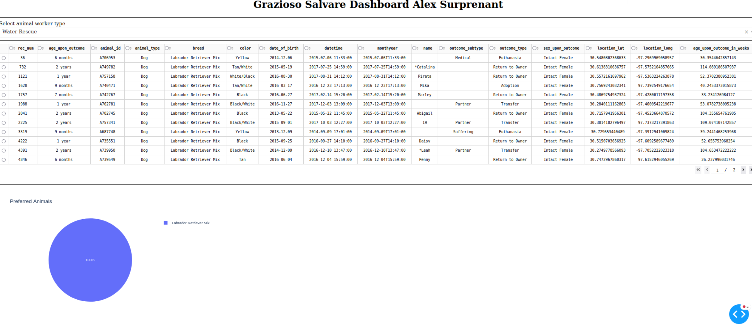

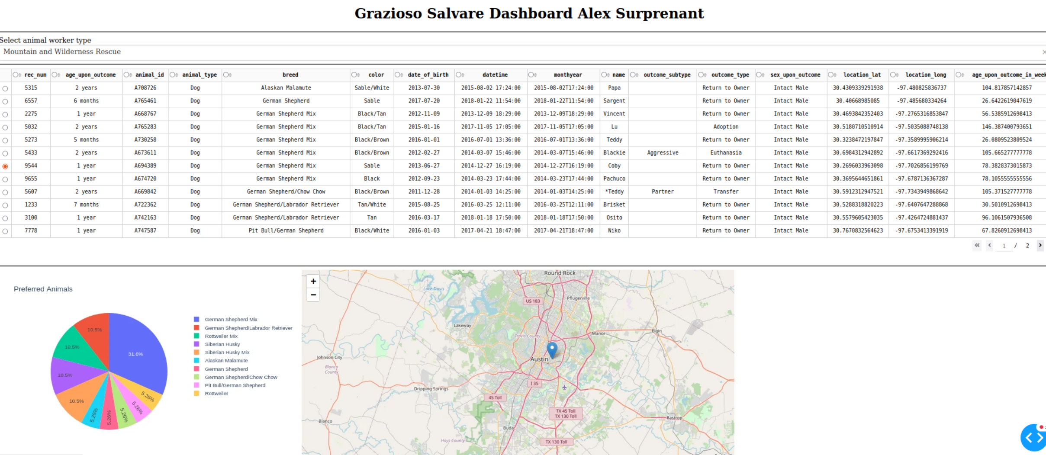

## Contact

Your name: Alex Surprenant

Github: <https://github.com/Soup098>